Poro-Acoustic Impedance as a New Seismic Inversion Attribute for Reservoir Characterization

Aftab, S.¹ | Leisi, A.¹ | Shad Manaman, N.¹ 

1. Department of Mining Exploration, Faculty of Mining Engineering, Sahand University of Technology, Tabriz, Iran.

Corresponding Author E-mail: shadmanaman@sut.ac.ir

(Received: 14 March 2023, Revised: 18 March 2023, Accepted: 2 May 2023, Published online: 20 Feb 2024)

Abstract
Porosity is one of the most important petrophysical parameters, studied in the subject of reservoir characterization. Determining porosity and how it changes in hydrocarbon reservoirs is an important issue that has been addressed in various researches. In this research, Poro-Acoustic Impedance (PAI) is introduced as an extended form of Acoustic Impedance (AI). The difference between PAI and AI is related porosity that is directly involved in the PAI. The inclusion of porosity data in the PAI formula made porosity effective in forward modeling and inversion of seismic data. The use of PAI in the forward modeling of synthetic models increases the contrast between the subsurface layers, and the contrast increases twice as compared to the AI. Band Limited Recursive Inversion (BLRI) algorithm is used for inversion of synthetic seismograms and model-based algorithm is used for real seismic data inversion. For real data, due to the existence of well data, seismic horizons and geological information, using the basic model method for inversion is more accurate. The main difference between inversion using PAI and AI is that changes in porosity can be seen directly in the results of PAI inversion. The correlation of porosity with PAI and AI is -0.93 and -0.85, respectively, which shows that porosity has a stronger relationship with PAI. The use of PAI can be a quick and simple solution to understand porosity changes in hydrocarbon reservoirs and increase the accuracy of porosity determination in reservoirs to a great extent.
Keywords: Poro-Acoustic Impedance, Reservoir Characterization, Seismic Inversion, Seismic Attributes, Inversion, Forward Modeling.

Introduction
Porosity is an important factors in the formation of hydrocarbon reservoirs. Many efforts have been made to determine porosity and its changes in hydrocarbon reservoirs, which is one of the main issues in reservoir characterization (Azevedo et al., 2020; Soares, 2021). The creation of a geological model using seismic data can be considered as the goal of reservoir characterization, which can be used to predict the distribution of petrophysical parameters such as porosity, permeability and saturation in a reservoir (Onajite, 2021; Leisi & Falahat, 2021). Seismic inversion is an important technique used for hydrocarbon reservoirs characterization. This approach enables us to integrate seismic and well logging data to predict rocks properties within the seismic survey area. In other words, seismic inversion is a technique for mapping subsurface rocks and fluids properties using

seismic records made on earth surface (Simm & Bacon, 2014; Maurya et al., 2020).
Seismic attributes are types of seismic measurements that facilitate the understanding of subsurface structures and make the desired exploration targets better detected in the inversion results (Onajite, 2021; Kadkhodaie-ilkhchi et al., 2014). A good seismic attribute is sensitive to the desired petrophysical feature in the studied reservoir, or it enables us to analyze and interpret the studied area correctly. In recent years, several articles have been published regarding the successful use of seismic attributes in the exploration of hydrocarbon reservoirs and the extraction of petrophysical characteristics of the reservoirs. Reservoir characterization using seismic data requires knowledge of seismic attributes and a technique to relate reservoir main properties such as porosity to the obtained data. Seismic

attributes divided into two main categories: quantitative and qualitative. Qualitative seismic attributes can be used to check the quality of seismic data and to check how good a seismic acquisition was. Also, qualitative seismic attributes can be used to determine seismic facies and interpret the sedimentary depositional environment. Quantitative seismic attributes are used for quantitative analysis of hydrocarbon reservoirs (Onajite, 2021; Simm & Bacon, 2014; Kadkhodaie-Ilkhchi et al., 2014). Therefore, by relating the quantitative attributes to the petrophysical properties of the reservoir, we can predict the changes in lithology, porosity, fluid saturation and contact between water and oil (Farfour et al., 2015).
Porosity is an important parameter for describing conventional reservoirs characteristics. Porosity study in hydrocarbon reservoirs considered as main concern for selecting a suitable and economic reservoir in hydrocarbon exploration industry (Farfour et al., 2015; Leisi & Saberi, 2022). Due to the importance of porosity in hydrocarbon reservoirs, many researchers have used different methods to determine porosity changes in different reservoirs. 3D porosity cube is estimated from AI cube using Artificial Neural Networks (ANN) and multi attribute regression in Iranian marine oil fields (Khoshdel & Riahi, 2011). Compressional wave velocity has been used for porosity estimation of sandstone reservoirs in Egypt by well-known methods (Kassab & Weller, 2011). Porosity- permeability models using Local Linear Neuro-Fuzzy Model (LLNFM) technique have also been used for Iranian giant carbonate reservoirs (Ghadami et al., 2015). Integrated petrophysical modeling has been used to model fractured and heterogenous carbonate reservoirs of southwest Iran, which was successful for modeling complex carbonate reservoirs (Shahbazi et al., 2020). Porosity models have been generated based on porosity relationship with diagenesis index using linear regression method (Wei et al., 2016). Also, the relationship between porosity and seismic attributes have been studied using bat-inspired optimization algorithm in Persian Gulf carbonate reservoirs (Gholami & Reza, 2017). Integration of seismic attributes, seismic
post-stack data and well logging data have been used for porosity estimation and reservoir characterization in Pakistan carbonate reservoirs (Ali et al., 2019). Knowledge-based seismic inversion was also reported as a new and efficient strategy for geologically complex reservoir modeling and characterization (Soleimani et al., 2016). In last decade use of artificial intelligence algorithms for reservoir characterization has been expanded. For example, joint inversion of Support Vector Machine (SVM) and Particle Swarm Optimization (PSO) algorithms has been used for determination of porosity spatial distribution using well logging and seismic data (Yasin et al., 2021). Normally, in the characterization of hydrocarbon reservoirs, the output of the inversion process is AI, which can be used to predict the density and P-wave velocity in the reservoir, and in the next step, porosity variations in the reservoir that are predicted using AI data. In other words, in this method, the porosity is not calculated directly in the inversion process (Khoshdel & Riahi, 2011; Grana et al., 2017; Lindberg & Grana, 2015). The innovation of this research is that introducing a new quantitative seismic attribute makes it possible to include the porosity distribution in the inversion results in addition to the density and P-wave velocity. This seismic attribute is, in fact, an extended form of AI, that is named “Poro- Acoustic Impedance (PAI)”. The use of this new attribute in the process of forward modeling and inversion will make the distribution of porosity, P-wave velocity, and density to be seen together in the inversion results.

Geology Setting
The studied oil field is one of the richest oil fields in Iran, which is in Khuzestan province and in the northwest of the Persian Gulf (Figure 1). The four reservoirs that produce oil in this field are Ghar, Asmari, Sarvak and Kazhdomi, in which Ghar reservoir will be investigated in this study. In terms of age, this reservoir is equivalent to the Ahvaz sandstone section and forms one of the well- known reservoir sections in the Persian Gulf region. This reservoir is mainly composed of quartz sandstones with dolomitic cement along with thin layers of sandy dolomites. The studied formation consists of three facies

including shale, loose sand and cement sand. 𝐏𝐀𝐈 = 𝛒^{𝑎}𝐕^{𝑏}(1 − 𝛗_{𝐞𝐟𝐟})^{𝑐} 𝑎 = 1.5, 𝑏 = 1, 𝑐 = 2 (1)
𝐏

In this formation, the presence of porous sand layers has created suitable conditions for hydrocarbon accumulation. This formation is divided into three zones in terms of reservoir quality; Ghar zone 1, 2 and 3 (Leisi et al., 2022; Kheirollahi et al., 2023). Among these zones, zone 3 has a better reservoir quality.

Methodology
In this study, we used PAI for both seismic forward modeling and inversion. We tested this attribute in both synthetic data and real seismic data. For the synthetic case we created a layered geologic model and for each layer, P-wave velocity, density and porosity were designated. Heterogeneity is considered in synthetic models so that the mentioned petrophysical parameters are not constant in each layer. At the first step, we produced synthetic seismic trace in model with use of convolution forward modeling, and in the second step, we used Band- Limited Recursive Inversion (BLRI) algorithm for mapping subsurface properties from generated seismic trace.
The data used includes seismic post-stack data, seismic horizons and three wells, each one with velocity, density and porosity logs.
where ρ is density, VP is P-wave velocity, φeff is effective porosity, and a, b, c are weighting factors of the density, P-wave velocity, and effective porosity respectively. Note that, rock physics studies were used to define the base state of the PAI equation and the result was that the inverse relationship
between porosity and density and velocity led to define a new seismic feature. However, to define the weight of each of the parameters of porosity, density and velocity, well logging data and machine learning algorithms have been used, and the weight of each of the mentioned parameters has been defined in such a way that the contrast between the geological layers was increased. The convolution method of forward modeling to generate a seismic trace using PAI is written as follows:
𝐒(𝐭) = 𝐏𝐑(𝐭) ∗ 𝑊(𝑡) + 𝐍(𝐭) (2)
where S(t) is seismic seismogram, PR(t) is Poro-reflection coefficients series, W(t) is wavelet, N(t) is noise component, and ∗ is convolution operator. The zero offset poro- reflection coefficients are also defined as follows:

From the four reservoirs that produce oil in this field, Ghar reservoir is investigated in
𝐏𝐑𝑖
= 𝐏𝐀𝐈𝑖+1−𝐏𝐀𝐈𝑖
𝐏𝐀𝐈𝑖+1+𝐏𝐀𝐈𝑖
(3)

this study. For the post-stack seismic inversion of the Ghar sandstone reservoir data, we used a model-based algorithm.
The PAI define as follows:
where PAIi is PAI of i^{th} layer, and PRi is poro-reflection coefficient between layers i^{th} and (i + 1)^{th} (Azevedo et al., 2020; Soares, 2021).

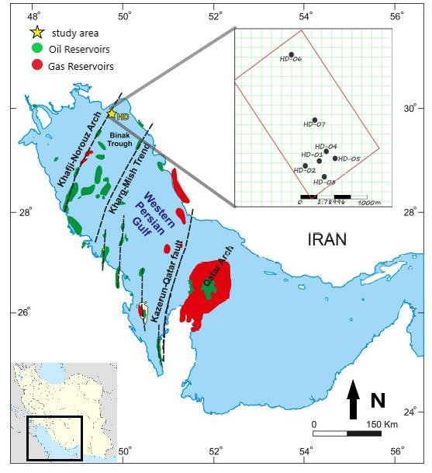
Figure 1. The Persian Gulf and hydrocarbon resources of western Persian Gulf. Study area indicated by yellow star.

The BLRI (Band Limited Recursive Inversion) algorithm considering PAI is defined as follows:
AI and the PAI with respect to the depth and are shown in Figure 4 and Figure 5, respectively. The maximum changes in

𝐏𝐀𝐈𝑖+1 = 𝑃𝐴𝐼1 exp(2 ∑^{𝑖}
𝐏𝐑𝑘 )
(4)
reflection coefficients obtained from PAI are

𝑘=1
Seismic post-stack data inversion algorithms
between -0.5 and 0.5 ^{𝑚}
𝑠
(
𝑔

𝑐𝑚3
) and the

is divided into main categories, deterministic
maximum changes for AI are between -0.2

algorithms and stochastic algorithms. Stochastic category includes model-based
and 0.2 ^{𝑚}
𝑠
(
𝑔

𝑐𝑚3
) The greater contrast

inversion methods and deterministic category includes band-limited inversion, sparse spike inversion, and colored inversion methods. The BLRI algorithm is one of the most common methods, which assumes that the seismic amplitude directly depends on earth reflectivities and transform seismic traces to subsurface rocks properties. All the results obtained from synthetic and real data are compared with the AI results and are presented in the results. The summary of this research methodology is shown in Figure 2.
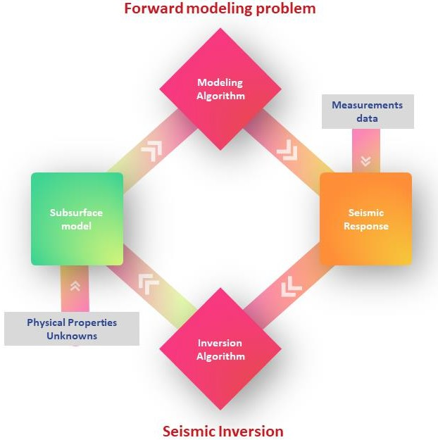
Figure 2. The relationship of forward modeling and inversion procedure. The figure shows brief explanation of the method used.

Results and discussion
As mentioned, the results of forward modeling and inversion using PAI have been compared with the AI results in synthetic models. Figure 3 shows the initial synthetic model for testing AI and PAI performances. The synthetic model is a vertical displacement (vertical fault) and the heterogeneities and anisotropy of the layers are considered in model. The signal-to-noise ratio is considered 7, and the performance of the AI and PAI during forward modeling and inversion are tested for this ratio. The reflection coefficients are obtained from the
between the layers in the reflection
coefficients obtained from the PAI (Figure 5) compared to the coefficients are obtained from the AI (Figure 4) which shows that the PAI has better resolution and more contrast than the AI. Increasing the contrast in the PAI relative to the AI has a positive effect on the seismic modeling. To generate a seismogram, the obtained reflection coefficients must be convolved with a wavelet (Liang et al., 2019). Seismic inversion results depend strongly on forward modeling procedure in generating synthetic seismogram (Silva et al., 2020; Anifowose et al., 2016). The minimum phase wavelet has been selected in order to convolve it with reflection series.
Synthetic seismic traces using AI and PAI are shown in Figure 6 and Figure 7, respectively. As with reflection coefficients, the seismic trace produced using PAI, creates a greater contrast than for the seismic trace produced by AI. The maximum seismic amplitude changes in AI are between -0.2 and 0.2, and the maximum changes in PAI are between -0.4 and 0.4, which has 50% more contrast than the AI (Figure 6) and (Figure 7).
Comparison of AI and PAI reflection coefficients and seismic traces shows that the performance of the PAI for separation layers with low contrast is better than that of AI. For example, the boundary between layer-2 and layer-3 is not detected in AI trace but is detected in PAI trace, and with increasing the noise and performance of AI are exacerbated. However, the noise effect on PAI results is not so significant and performance of PAI for noisy data is acceptable (Figure 6 and Figure 7), and due to the results of mentioned figures, it can be concluded that the PAI is resistant against noise; however, the AI is affected more by noise. In addition, if the physical properties of the layers are not much different with each other, the performance of the PAI for detection of individual layers is much better than AI.

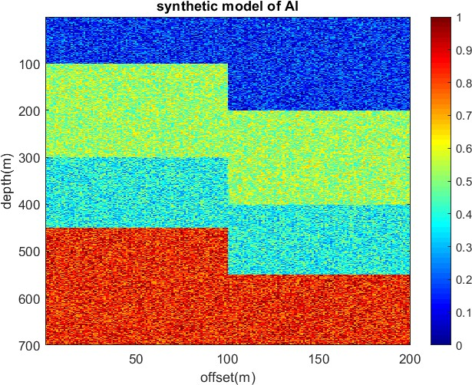
Figure 3. The synthetic model used to forward modeling and inversion with considering heterogeneity and anisotropy in model. The model is a vertical displacement (normal fault model) in which the left side is foot wall and the right side is hanging wall. The AI is normalized between 0 and 1.
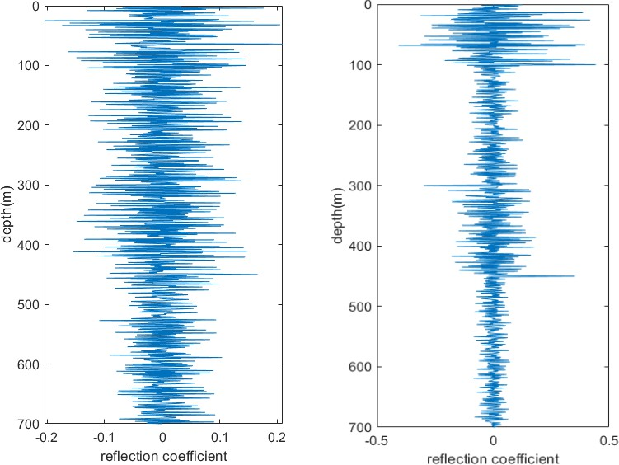
(a) AI (b) PAI
Figure 4. (a) Reflection coefficients obtained from AI in left side of the model (foot wall), offset=50 m, (b) Reflection coefficients obtained from PAI in left side of the model (foot wall), offset=50 m. Signal to noise ratio: 7.
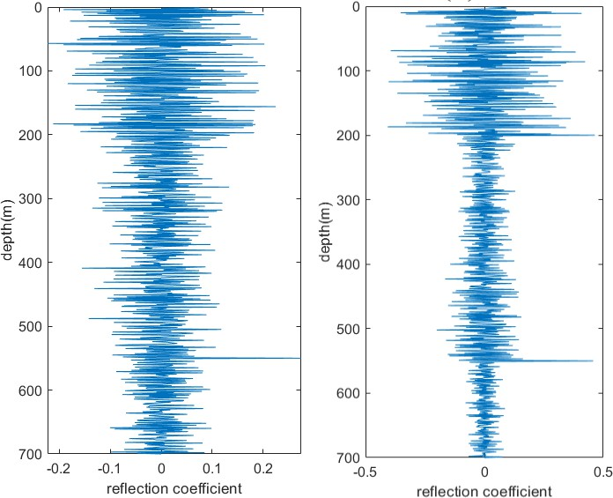
(a) AI (b) PAI
Figure 5. (a) Reflection coefficients obtained from AI in right side of the model (hanging wall), offset=150 m, (b) Reflection coefficients obtained from PAI in right side of the model (hanging wall), offset=150 m. Signal to noise ratio: 7.

The increase in contrast in the created seismic traces makes the separation between the subsurface layers more accurate and easier. Increasing the contrast is especially important in detecting the boundary of the reservoir layers, because the correct and accurate determination of reservoir boundaries allows the subsequent processing and interpretation to be done with sufficient accuracy. In addition, increasing the contrast can be very helpful in detecting seismic horizons, because seismic horizons are very important in building the initial model for inversion and in interpreting seismic data.
The question that arises here is why the seismic trace and reflection coefficients obtained using PAI have more and better contrast than the AI. The answer is that the biggest difference between the reservoir layers and the adjacent layers is in the amount of porosity. In forward modeling using PAI, the effect of porosity parameter is included in Equation (1). Density and
porosity parameters are strongly dependent on porosity and often change together. Multiplying these three parameters in Equation (1) increases the contrast in subsurface models. Note that in Equation (1), the porosity term has more weight than the density and P-wave velocity, and because the biggest difference between the reservoir layers and the adjacent layers is in the amount of porosity, so the contrast between subsurface layers is intensified.
The variation of seismic amplitude results from AI and PAI for synthetic model are showed in Figure 8. In Figure 8, it is clear that the boundary between layer-2 and layer-
3 is detected very weak in AI seismic amplitude section. However, this boundary is detected clearly in PAI amplitude section. Also, the layers' boundary is detected with more contrast in PAI section in comparison with AI section. In addition, the heterogeneity of alluvial deposits (first layer) in synthetic model is more visible in PAI amplitude section.

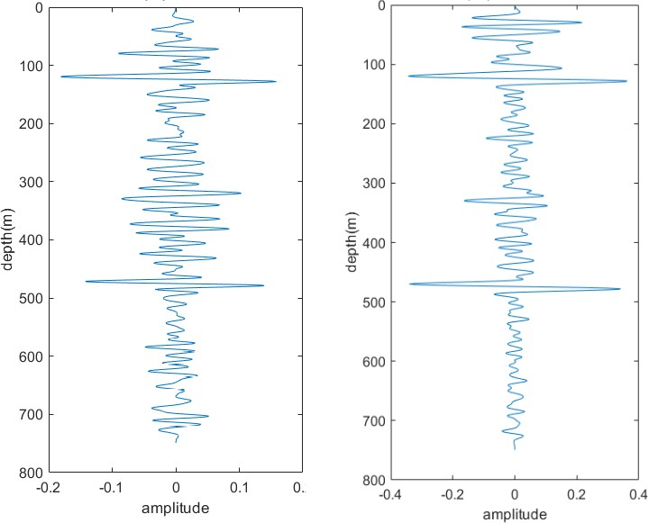
  - AI (b) PAI
Figure 6. (a) Seismic trace obtained from AI in left side of the model (foot wall), offset=50 m, (b) Seismic trace obtained from PAI in left side of the model (foot wall), offset=50 m. Signal to noise ratio: 7.
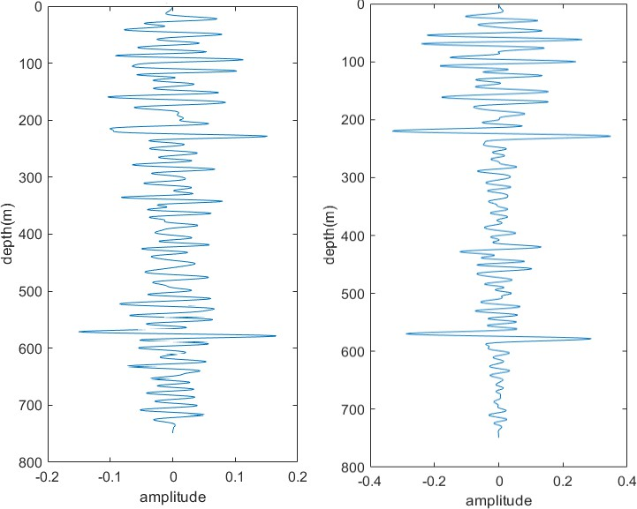
(a) AI (b) PAI
Figure 7. (a) Seismic trace obtained from AI in right side of the model (hanging wall), offset=150 m, (b) Seismic trace obtained from PAI in right side of the model (hanging wall), offset=150 m. Signal to noise ratio: 7.

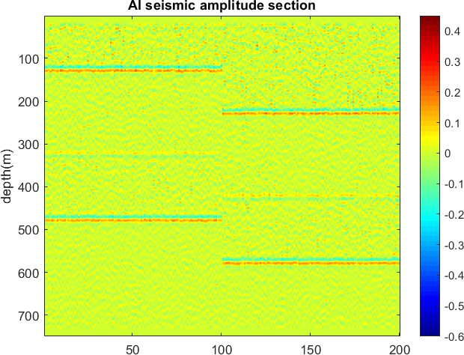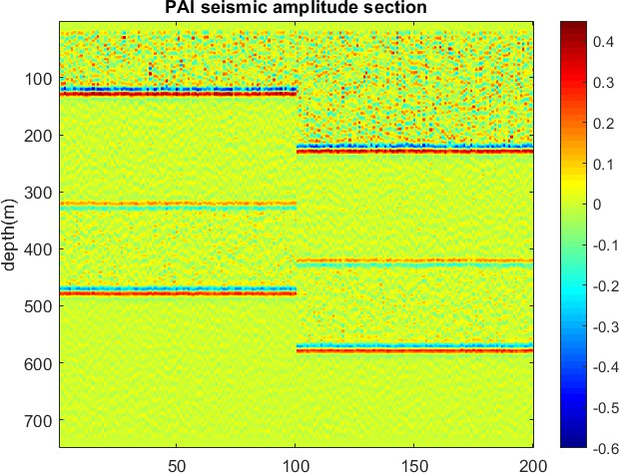

(a) | (b)
Figure 8. (a) Seismic amplitude variation section using AI, (b) seismic amplitude variation section using PAI.

The next question that arises is what is the advantage of inversion using PAI? The main advantage of using PAI is that, in addition to density and velocity, porosity is also included in the modeling and inversion process, and if it is necessary to estimate porosity in the reservoir, using PAI can be better, because the correlation between porosity in PAI is higher than that of AI, which will be explained later on this issue in real data. Inversion is also performed using BLRI algorithm for PAI and AI. Comparison of the inversion results of PAI and AI shows that the synthetic model structure in PAI inversion result is clearly detected; however, in AI case, the inversion result could not
reconstruct the synthetic model correctly (Figure 9). The inversion RMSE using AI and PAI are 12% and 9%, respectively. Due to the results of the AI and PAI forward modeling and inversion, we can conclude that the seismic attribute affects directly the reconstruction of initial model during inversion procedure and RMSE results prove this pretension.
In the study of synthetic models, the use of PAI in the forward modeling procedure increased the contrast and in the inversion stage, it caused the porosity changes to be directly observed in the inversion results. The next step is to test the PAI on real data.

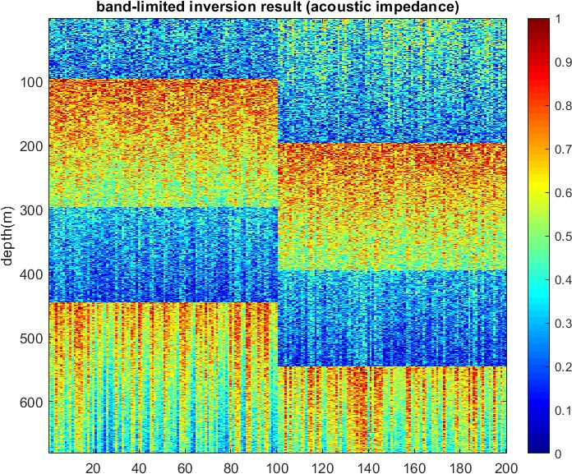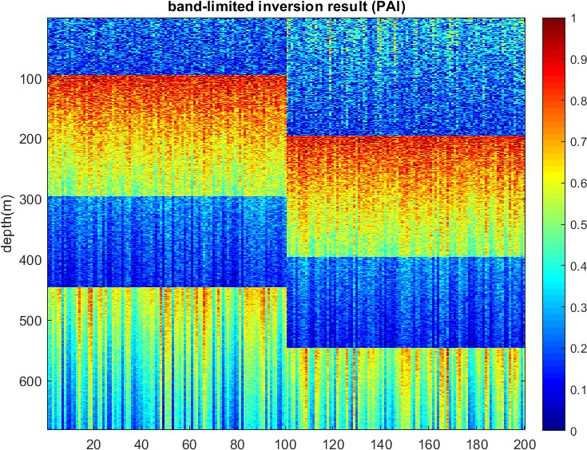

Figure 9. The inversion results of PAI and AI using BLRI algorithm. The inversion results normalized between 0 and 1 to be comparable.

Well-logging data from three wells have been used for seismic inversion. Before the inversion process, the correlation of porosity, density and velocity with AI and PAI is investigated. The P-wave velocity has a higher correlation with the AI than the PAI (Figure 10). The correlation of P-wave velocity with the AI is 0.98 and the correlation of the P-wave velocity with PAI is 0.95 that is 3% less than the AI. According to Equation (1), the velocity has less weight in comparison with density and porosity, and the low correlation of the velocity with PAI is normal. The correlation between density and AI is not very different. The correlation between density with AI is
0.89 and with PAI is 0.88 (Figure 10). Therefore, it can be stated that the correlation of density with PAI is also acceptable.
Correlation of porosity with AI and PAI is different. The correlation between PAI and porosity is -0.93 and the correlation between porosity and AI is –0.85. There is a significant difference in the correlation of porosity because porosity is directly contributing in the PAI formula, and in addition, the weight of the porosity term in the PAI formula is greater than that of density and velocity (Figure 12). It should be noted that the relationship between porosity, density and velocity parameters with AI are linear, but their relationship with PAI are a quadratic polynomial. Because the PAI Equation is written as a power Equation, the correlation between porosity, density and velocity with PAI is expressed as a quadratic Equation, and the use of a linear Equation is not appropriate in this case.

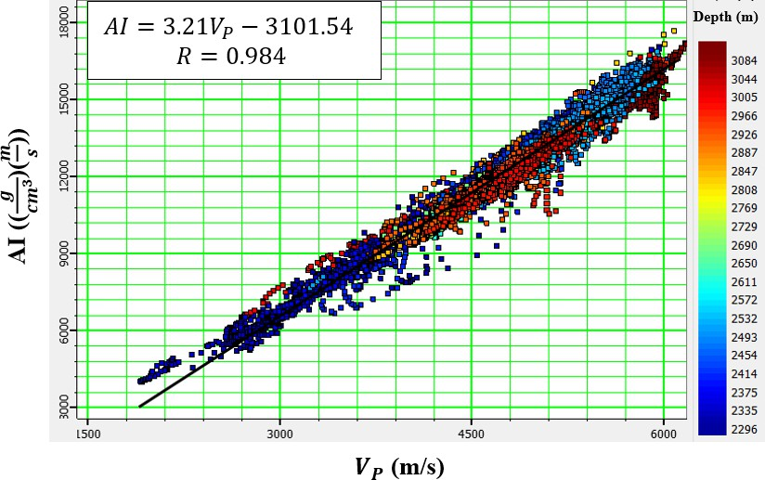
(a)
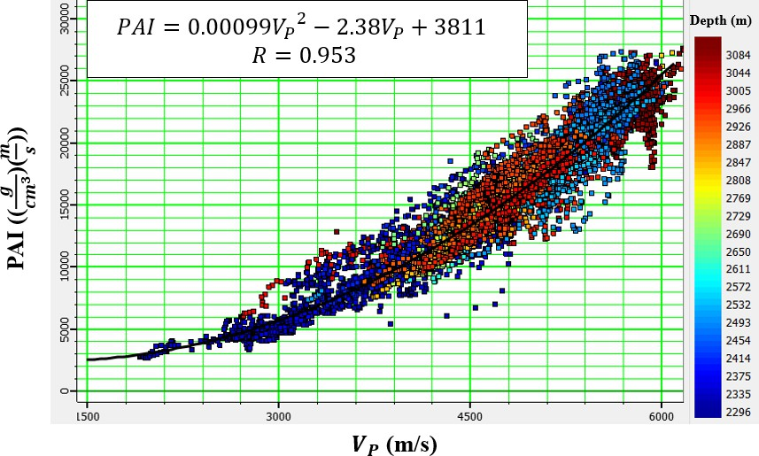
(b)
Figure 10. (a) Cross plot and correlation between P-wave velocity and AI (AI), which has been found to be linearly related to velocity and AI. (b) The cross plot and correlation between P-wave velocity and PAI, which has been found to be a quadratic polynomial (three wells’ data included).

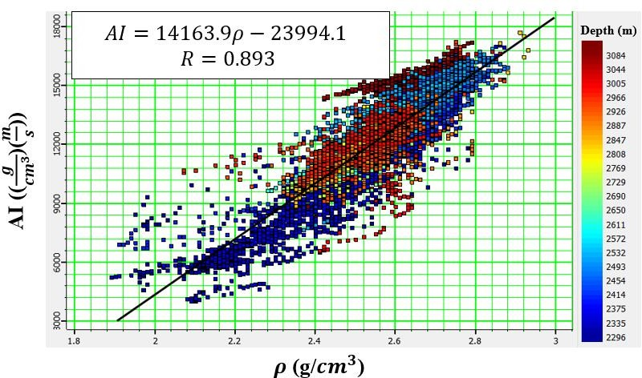
(a)
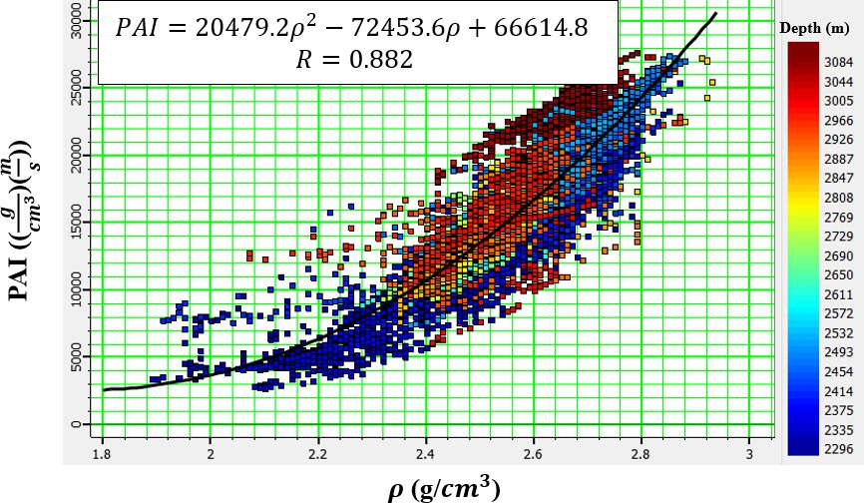
(b)
Figure 11. (a) Cross plot and correlation between density and AI (AI), which has been found to be linearly related to density and AI. (b) cross plot and correlation between density and PAI, which has been found to be a quadratic polynomial (three wells’ data included).
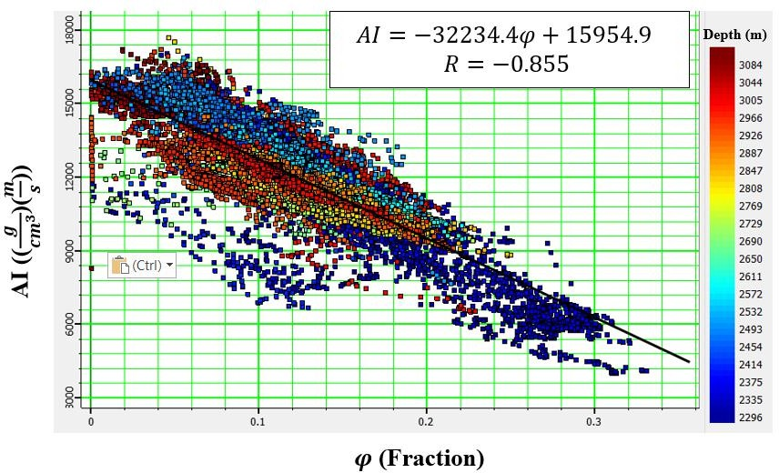
(a)

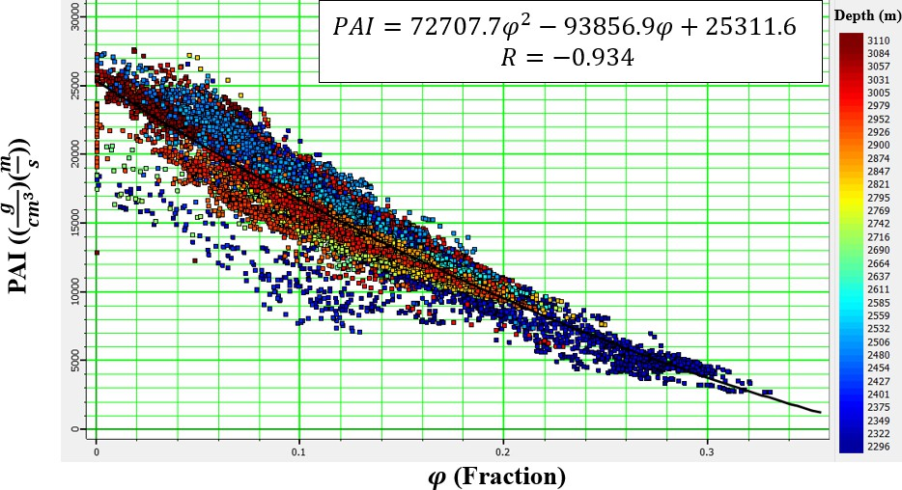
(b)
Figure 12. (a) Cross plot and correlation between porosity and AI (AI), which has been found to be linearly related to porosity and AI. (b) cross plot and correlation between porosity and PAI, which has been found to be a quadratic polynomial (three wells’ data included).

As mentioned earlier, model-based seismic inversion algorithm was used to calculate the AI in this study. The average correlation and error between the real and estimated AI using the model-based seismic inversion algorithm at the location of the wells is 0.9915 and 0.2013, respectively. Table 1 shows the correlation and error between the actual and estimated AI using the model-based seismic
inversion algorithm at the location of each well.
Figure 13 shows the correlation and error between the real seismogram and the synthetic seismogram resulting from the model-based seismic inversion algorithm at the location of well No. 3, which indicates an error of 0.1959 and a correlation of 0.9957.

Table 1. The correlation and error between the actual and predicted AI at the location of each well.

Well number | Correlation | Error
1 | 0.9951 | 0.2164
2 | 0.9894 | 0.1679
3 | 0.9957 | 0.1959
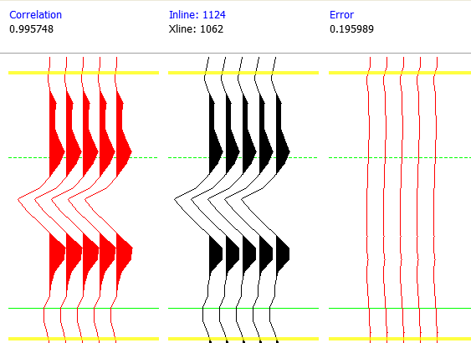
Figure 13. From left to right, synthetic seismogram, real seismogram and error using AI inversion.

The average correlation and error between the actual and estimated PAI using the model-based seismic inversion algorithm at the location of used wells are 0.9941 and 0.2117, respectively.
Table 2 shows the correlation and error between the actual and estimated AI using the model-based seismic inversion algorithm
at the location of each well.
Figure 14 shows the correlation and error between the real seismogram and the synthetic seismogram of PAI resulting from the model-based seismic inversion algorithm at the location of well No. 3, which indicates an error of 0.2117 and a correlation of 0.9968.

Table 2. The correlation and error between the actual and predicted PAI at the location of each well.

Well number | correlation | error
1 | 0.9933 | 0.2225
2 | 0.9952 | 0.2196
3 | 0.9968 | 0.2117
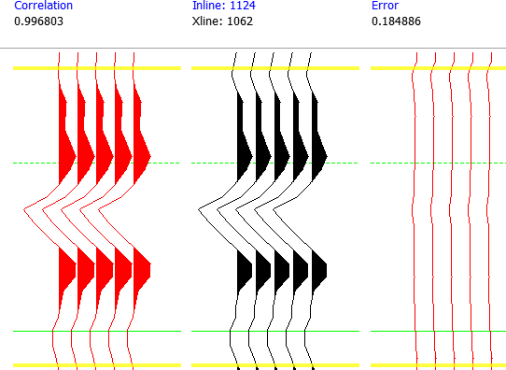
Figure 14. From left to right, synthetic seismogram, real seismogram and error using PAI inversion.
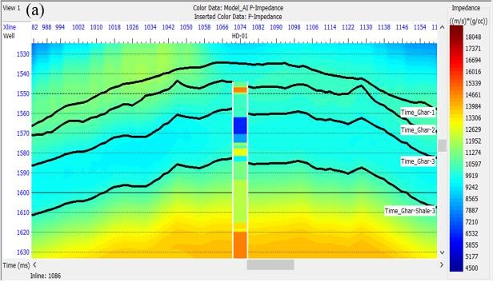
(a)

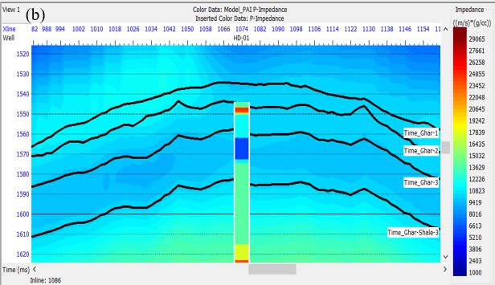
(b)
Figure 15. (a) The initial model of AI, (b) The initial model of PAI at the location of well No. 1.
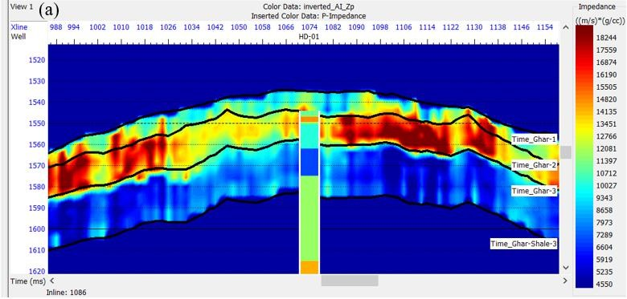
(a)
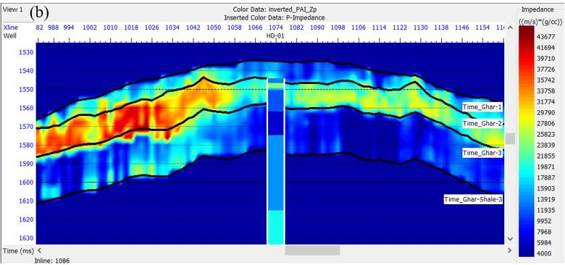
(b)
Figure 16. (a) the AI cross-section with AI log, (b) the PAI cross-section with PAI log at the location of well No. 1.

The initial (low frequency) models for AI and PAI are illustrated in Figure 15, and these initial models are used in seismic inversion procedure.
In the section of AI in Ghar 1 and 2, drastic changes in sound impedance can be seen. Considering that the inversion has been done in the reservoir zones, it is expected that the AI is low in the reservoir layers, while high values are also observed in the AI section. In the PAI section, extreme changes in the mentioned zones have become smoother.
In addition, from the studies of drilling core samples and analysis of thin sections, it is determined that Ghar 3 has better quality and porosity than other zones (Figure 16). Finally, the main difference between AI and PAI sections is that porosity changes can be interpreted directly in the PAI section because the porosity parameter is included in the PAI method.
In comparison of the inversion result of AI and PAI, it should be stated that it is not
logical to choose which of the inversion results is better. Because, AI and PAI are not the same, and the inversion results of these seismic attributes will definitely be different. However, using PAI instead of AI has some advantages. The direct involvement of porosity in the PAI equation makes the interpretation of porosity changes using PAI more reliable compared to AI (Figure 12). In addition, one of the important factors controlling the reservoir quality is porosity, and due to the inclusion of porosity in the PAI equation, PAI can also be used to interpret the reservoir quality.
AI, as a well-known seismic attribute, has been used for years for forward modeling and inversion of seismic data. However, investigating the relationship and correlation between AI and PAI is also an important issue. The correlation between AI and PAI in well data is shown in Figure 17, and the correlation between PAI and AI in seismic data is shown in Figure 18.

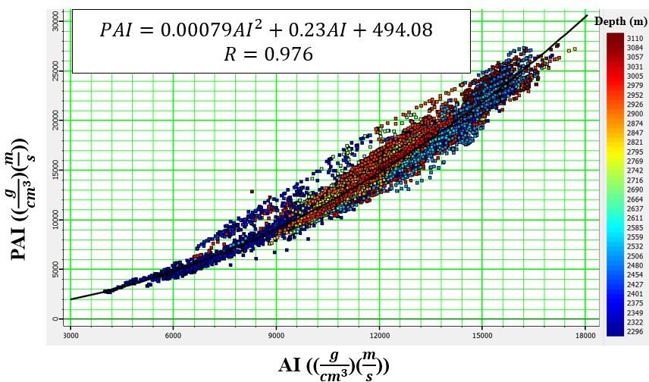
Figure 17. The cross plot between AI and PAI for used well data (three wells' data integrated). The relationship between PAI and AI introduced as quadratic polynomial.
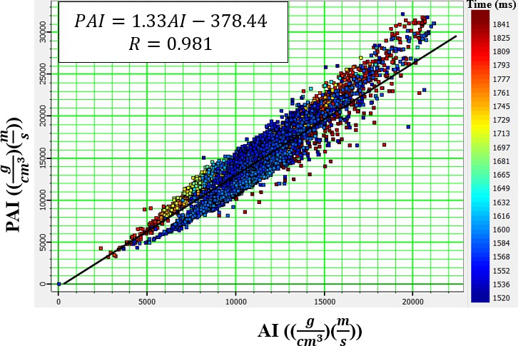
Figure 18. The cross plot between AI and PAI for seismic data in XLINE= 1074. The relationship between PAI and AI is linear.

Conclusion
According to the results obtained from this research, it can be stated that PAI is a very useful and simple seismic attribute that can be used for forward modeling and inversion of seismic data. The use of PAI increases the contrast in seismic traces, and as a result, the separation of subsurface layers is done more accurately. Inversion using PAI causes that the porosity variation can directly be seen in inversion results. Correlation of porosity with PAI is also higher than AI, and this makes the interpretation and estimation of porosity through PAI more accurate. The most important characteristic of reservoir layers is the presence of appropriate porosity in these layers. For this reason, porosity has been directly included in PAI Equation, in order to perform better than AI in the identification of hydrocarbon reservoirs. In addition, in the PAI Equation, porosity has more weight than density and P-wave velocity, so that the role of porosity in the inversion results is greater. Note that, the PAI can be introduced as a robust index for reservoir quality evaluation. It is suggested to use PAI in the inversion of carbonate reservoirs seismic data and obtain its results. Additionally, other extended versions of AI using petrophysical parameters can be provided to be used in all aspects of reservoir characterization.

